Abridged Professional Artist Resume
Qualifications:
Masters of Teaching (Secondary) (Art) Australian Catholic University 2017—2019
Masters in Fine Arts (Ceramics) Indiana University 2011-2014
Bachelor of Applied Arts (Ceramics) (Honours) 1999-2002

Selected Solo Exhibitions:
May 2021 Mum Voice, Corner Store Merchants, Castlemaine
Sept 2016 This Charming Man, Corner Store Merchants, Castlemaine

August 2016 No Such Thing as Social Sport, Antony DiMase Architects, Brunswick St, Fitzroy

April 2014 A Temporary Victory, Grunwald Gallery, Bloomington, Indiana, USA

Aug 2013 Dogs of the West Village, Greenwich House Pottery Studio, New York, NY, USA
June 2009 Raining in My Heart – Pieces of Eight Gallery, Brunswick St, Fitzroy
July 2007 Domestic Flights – Bus Gallery, Little Lonsdale Street, Melbourne

Selected Group Exhibitions:

Mar 2022 Triceratops exhibition, artwork at Melbourne Museum Shop, Melbourne, Australia

Jan 2021 All Dressed Up (nowhere to go), Corner Store Merchants, Castlemaine, Australia

May 2019 Weddings, Parties, Anything, Neighborhood Justice Centre, Collingwood, Australia

Feb 2018 International Women’s Day Exhibition, Third Drawer Down, Victoria, Australia

April 2017 Slice of Life – curated by Sophia Cai, Craft Victoria, Australia

Oct 2015 The Space that Binds Us, Natimuk, Victoria, Australia

Jun 2015 City of Hobart Art Prize, Hobart, Tasmania, Australia

Dec 2014 Faux Museum, c3 contemporary artspace, Abbotsford, Victoria, Australia

Feb 2014 The Now! Body – A One-Night, Life Changing, All-Over Body X-Treme New Power

Revolution, Fuller Projects, Bloomington, Indiana, USA

Sept 2011 The Machine, Craft Victoria, Melbourne, Australia (Curator) opened by Stelarc

June 2011 The Numan, c3 contemporary artspace, Abbotsford, Australia

Oct 2010 Third Dimension, Arts Project Australia Gallery, Northcote, Australia (Co-curator)

Sept 2010 Momentus, Mary E Black Gallery, Halifax, Nova Scotia, Canada

Oct 2009 Bottled – Pan Gallery Award Show, Brunswick, Australia (Winner)

Oct 2009 By Hand – Arts Project Australia Gallery, Northcote, Australia (Curator)
Oct 2009 Veni, Vidi, Vici – c3 contemporary artspace, Collingwood, Australia
June 2008 Gen and Kate Visit the Neighbours – Sideroom Gallery, Auckland, New Zealand

Grants and Awards:
2019 Artist-in-Residence Project at Catholic Regional College North Keilor
2018 Creative Victoria - Creative Learning Partnership with Shepparton Art Museum and Mooroopna Secondary College
2017 Creative Victoria - Artist-In-Schools Grant for residency at Coburg Special Development School and Coburg North Primary School
2011 - 2014 Masters of Fine Arts (paid Associate Instructor with free tuition)
2013 Ceramic “Holiday” Award Winner, Indiana University
2009 Pan Gallery Ceramic Award Prizewinner
2006 City of Melbourne – Artist Grant to produce solo exhibition Domestic Flights
2006 Arts Victoria - Artist-In-Schools Grant for residency at Heidelberg Primary School

2005 Craft Victoria Craft-In-Site Grant to support solo exhibition “Public Surface”
2005 Ian Potter Cultural Trust Grant for residency and study in Denmark
2002 Monash University D.W. Rogers Award
1999-2001 Monash University Dean’s Scholar

Selected Publications:
Creswell-Bell, A. Clay: contemporary ceramic artisans. NY, NY: Thames & Hudson, 2017.
Barry, R. and Jobson, R. The Craft Companion. London: Thames & Hudson, 2016.
Jacobs, K. Precious Moments and Pure Work, Journal of Australian Ceramics, Issue 50/1, 2012,
p 84-87
Rule, D. Around the Galleries, The Age Newspaper, Saturday November 7, 2009, p 20

Speaking and Presentation Experience
2017 Presenter: Inspiration and Influences (with Chris Pittard and John Tuckwell) for Slow Clay Centre – Pottery Expo Warrandyte
2016 Radio Interview for Artswank on Main FM (Castlemaine)
2015 Artist Talks at Spaces that Bind Us exhibition, Natimuk Frinj Festival, Victoria, Australia
2013 Guest Speaker Brickhouse exhibition at Indiana University East, Richmond, Indiana, USA
2011 Guest Speaker Making Objects Personal Conference/Seminar, RMIT, Melbourne
2009 Presentation of Paper Vision and Visibility – Imagining the Inclusive Contemporary Arts, Australian Ceramics Triennale, Sydney
2009, 2011 Curator talks at Arts Project Australia on exhibitions By Hand, The Third Dimension
2007 Artist Talk Selekta exhibition, Westspace Gallery in Melbourne, Australia

Artist Residencies
Greenwich House Pottery, New York City, July/Summer 2013
Nova Scotia Centre for Craft and Design Residency, Halifax, Nova Scotia, July/Summer 2010
Heidelberg Primary School, Heidelberg, Victoria, Australia July 2006
Guldagergaard Ceramic Centre, Skaelskor, Denmark, July/Summer 2005

References
Sim Luttin - Gallery Manager, Arts Project Australia
E: Sim.Luttin@artsproject.org.au
T: 9842 4484
M: 0437 448 758

Alison Eggleton – Curator, Horsham Regional Art Gallery
E: Alison.Eggleton@hrcc.vic.gov.au
T: (03) 5382 9579
M: 0438 516 150

About Me:

I am passionate about inclusive and arts-based education, specifically in areas of ceramics and sculpture, social practice and interactive art experiences, and art history.

As the Ceramics Program Co-ordinator at non-profit organization Arts Project Australia, I facilitated and supported the production of artwork by artists. I promoted their work and advocated for their inclusion in contemporary art practice. These artists often had diverse hearing, vision or speaking capacities, which necessarily inspired me to creatively problem-solve using non-verbal languages. This role informed my current view of art as a space in which every individual’s distinct vision of the world is both possible and valued.

My diverse range of teaching roles (Malmsbury Youth Justice Centre, Arts Project Australia and various retail positions) means I am confident working with a broad range of people, supporting the art practice of various people in many contexts. I have solid technical knowledge of ceramics and kiln-firing, and have completed both outdoor and indoor project installations.

As a teacher and an artist, I have excellent organisational skills, managing lead-times, deadlines, materials and resources required when planning projects, to ensure that I am accountable. As an example of this, I have been successful in attaining and acquitting various grants and art prizes, including recent Creative Victoria Learning Partnerships in 2017 and 2018.

Artist Specialties

I can offer residencies that focus on:

- Ceramics teaching for teachers (kiln-firing refreshers, ceramic studio best practice with key information required for safe glazing, firing, clean-up and storage of ceramic work)
- Collaborative learning for students (enhancing creative approach to artmaking, ideas development, task-sharing and co-operation between students for a shared goal)
- Physical artwork outcomes such as ceramic mosaic murals, acrylic painted wall murals, indoor sculptural artworks or installations, designed in collaboration with students.

Previous Projects

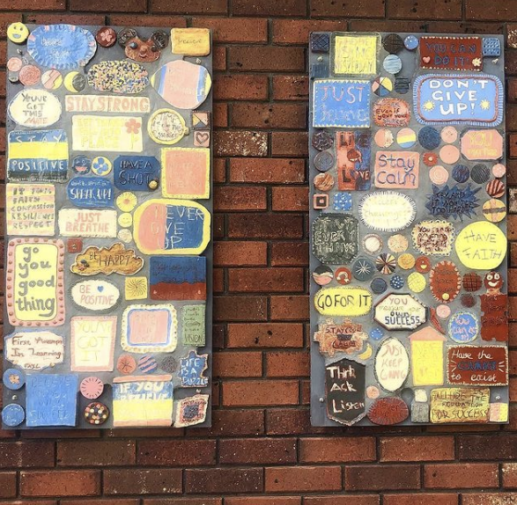
As part of a residency at Catholic Regional College North Keilor in 2019, students collaborated and brainstormed ideas using the prompt “think of something supportive you could say to a friend if they were doing something difficult”.

Students decorated tiles using ceramic slips and key statements such as “Don’t give up”, “Go for it” and “You got this”. I grouted and arranged these to form an uplifting mosaic mural for a wall in the senior student area. The intention for the prompt was to take the focus off the self, but which could also be applied to yourself as a positive mantra.

For a Creative Victoria grant in 2018, I designed a project to create giant trophies as a collaborative group project, aimed to connect students from Mooroopna High School to each other, their goals and ideas, and the kinetic and therapeutic properties of clay. This was conducted at Shepparton Art Museum where the students were invited to participate in gallery walks and connect with their local art institution to promote art education opportunities which may not be available to all students naturally.

